The Machine Learning Canvas (v0.4) Designed for: Designed by: Date: Iteration: .
  Decisions  How are predictions used to make decisions that provide the proposed value to the end-user?  No decision will be taken with this AI |   ML task  Input, output to predict, type of problem.  Binary Classification problem.  Input : one row for one person  Output : a probability between 0 and 1 |   Value Propositions  What are we trying to do for the end-user(s) of the predictive system? What objectives are we serving?  The main goal is to predict if someone has a yearly salary over 50k$.  Developper of the AI : Nathan Lauga nathan.lauga@protonmail.com  End user will be able to see the prediction of the AI by entering informations on a webapp. |   Data Sources  Which raw data sources can we use (internal and external)?  Adult dataset - external https://archive.ics.uci.edu/ml/datasets/adult | 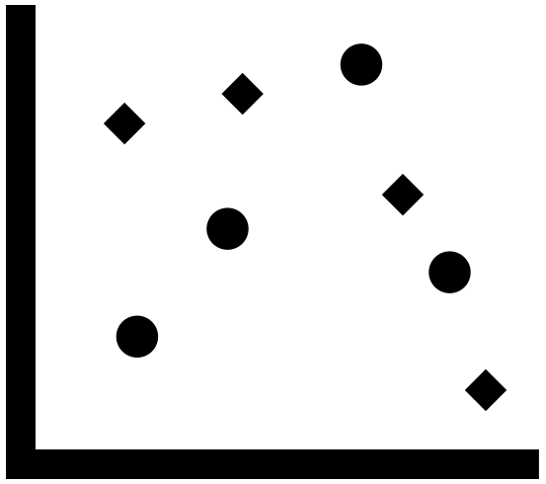  Collecting Data  How do we get new data to learn from (inputs and outputs)?  Download from the website
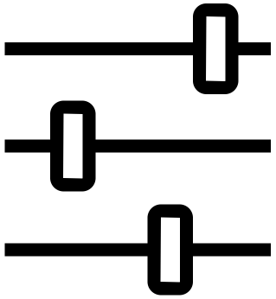  Making Predictions  When do we make predictions on new inputs? How long do we have to featurize a new input and make a prediction?  When the user enter the information on the webapp |   Offline Evaluation  Methods and metrics to evaluate the system before deployment.  Accuracy, F1 Score, precision & recall |  | 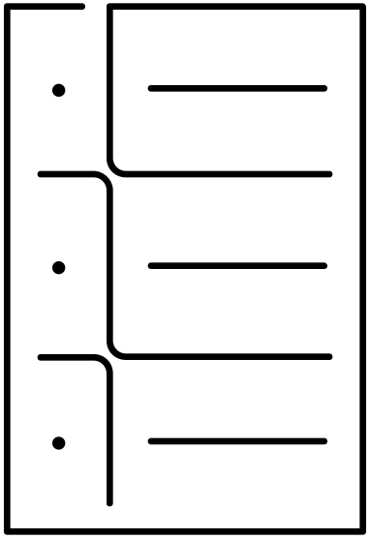  Features  Input representations extracted from raw data sources. |   Building Models  When do we create/update models with new training data? How long do we have to featurize training inputs and create a model?  Since data is static : never update.
 | Live Evaluation and Monitoring  Methods and metrics to evaluate the system after deployment, and to quantify value creation. | Impossible to follow this model in time | 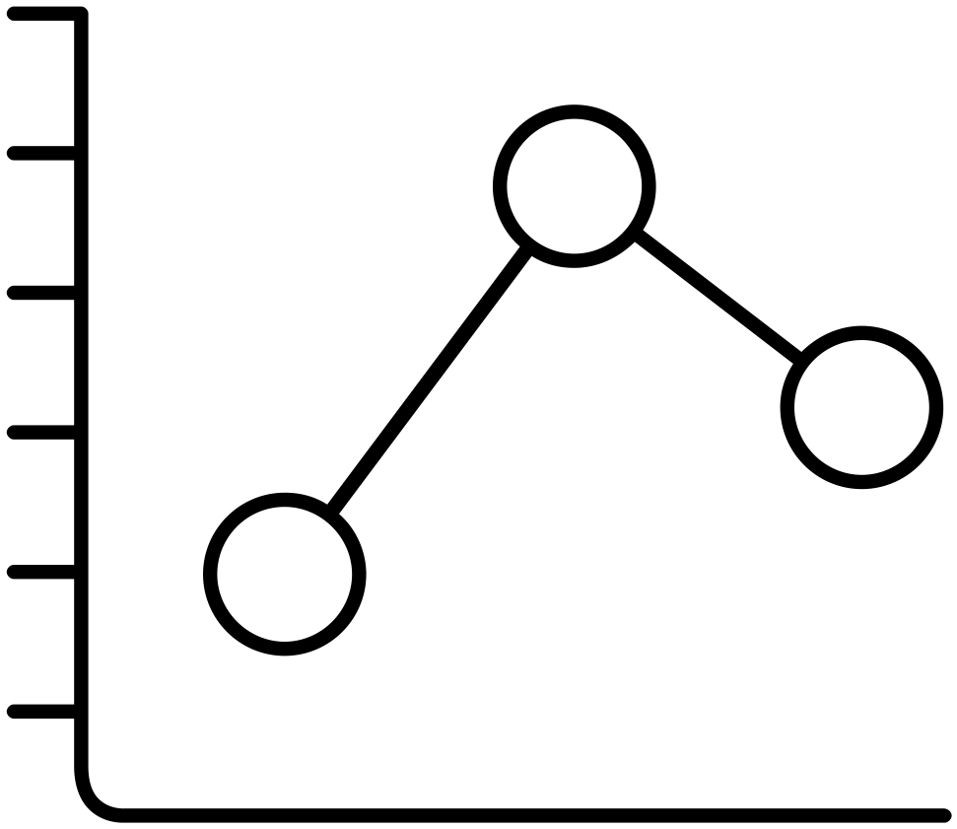
machinelearningcanvas.com by Louis Dorard, Ph.D. Licensed under a Creative Commons Attribution-ShareAlike 4.0 International License.

